SET 26 — STUDENT DATA ANALYSIS
R PROGRAMMING AND TABLEAU
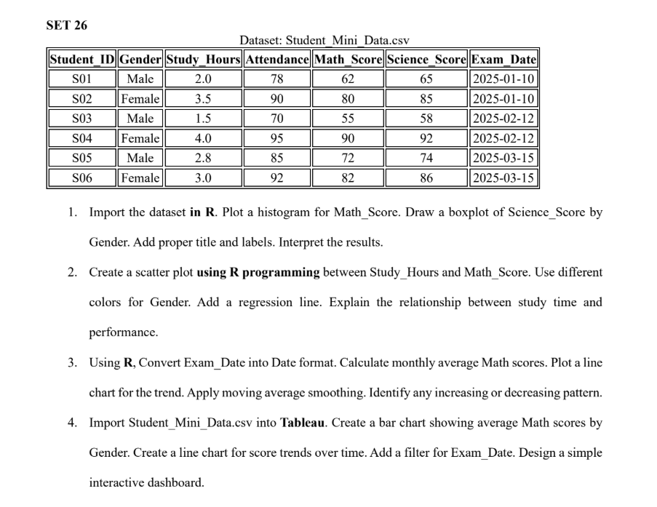

Dataset
The following six student records are used in the R analysis and Tableau dashboard.
Student_ID | Gender | Study_Hours | Attendance | Math_Score | Science_Score | Exam_Date
S01 | Male | 2.0 | 78 | 62 | 65 | 2025-01-10
S02 | Female | 3.5 | 90 | 80 | 85 | 2025-01-10
S03 | Male | 1.5 | 70 | 55 | 58 | 2025-02-12
S04 | Female | 4.0 | 95 | 90 | 92 | 2025-02-12
S05 | Male | 2.8 | 85 | 72 | 74 | 2025-03-15
S06 | Female | 3.0 | 92 | 82 | 86 | 2025-03-15
CSV file: Student_Mini_Data.csv (provided with this document as a separate file).

Q1. Histogram and Boxplot

Aim
Import Student_Mini_Data.csv, visualize the distribution of Math_Score with a histogram, and compare Science_Score between genders using a boxplot.

R Code / Procedure
# Q1: Histogram of Math_Score and Science_Score boxplot by Gender
students <- read.csv("Student_Mini_Data.csv", stringsAsFactors = FALSE)
# Histogram
hist(students$Math_Score,
main = "Distribution of Math Scores",
xlab = "Math Score",
ylab = "Number of Students",
col = "skyblue",
border = "white")
# Boxplot by gender
boxplot(Science_Score ~ Gender, data = students,
main = "Science Scores by Gender",
xlab = "Gender",
ylab = "Science Score",
col = c("lightpink", "lightblue"))

Output Screenshot

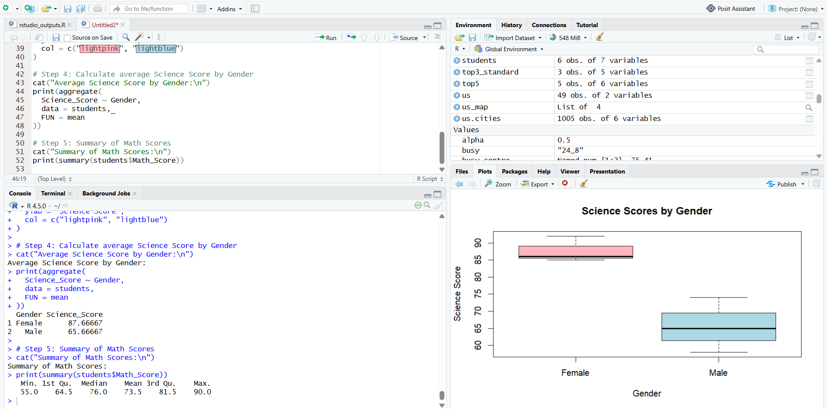

Result and Interpretation
Math scores range from 55 to 90. The histogram shows the spread of the six students' scores, with several scores in the 70–90 range.

Q2. Scatter Plot and Regression Line

Aim
Study the relationship between study hours and mathematics performance, distinguish students by gender, and add a linear regression line.

R Code / Procedure
# Q2: Study Hours vs Math Score with gender colours and regression line
library(ggplot2)
students <- read.csv("Student_Mini_Data.csv")
ggplot(students, aes(x = Study_Hours, y = Math_Score,
colour = Gender)) +
geom_point(size = 3) +
geom_smooth(method = "lm", se = FALSE,
colour = "black", linetype = "dashed") +
labs(title = "Study Hours vs Math Score",
x = "Study Hours",
y = "Math Score",
colour = "Gender") +
theme_minimal()
# Correlation and regression coefficients
cat("Correlation:", cor(students$Study_Hours,
students$Math_Score), "\n")
model <- lm(Math_Score ~ Study_Hours, data = students)
print(summary(model))

Output Screenshot
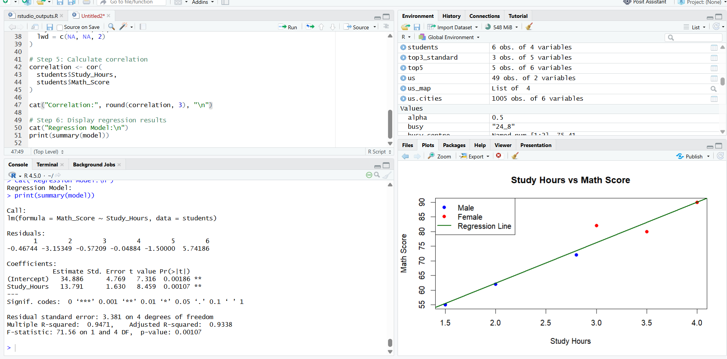

Result and Interpretation
The correlation between Study_Hours and Math_Score is approximately 0.973. The fitted regression slope is 13.79 score points per additional study hour.

Q3. Date Conversion, Monthly Average and Moving Average

Aim
Convert Exam_Date to R Date format, calculate monthly average Math_Score, plot the trend and apply moving-average smoothing.

R Code / Procedure
# Q3: Convert dates, calculate monthly averages and smooth trend
library(ggplot2)
students <- read.csv("Student_Mini_Data.csv",
stringsAsFactors = FALSE)
students$Exam_Date <- as.Date(students$Exam_Date,
format = "%Y-%m-%d")
monthly <- aggregate(Math_Score ~
format(Exam_Date, "%Y-%m"),
data = students, FUN = mean)
names(monthly) <- c("Month", "Average_Math_Score")
monthly <- monthly[order(monthly$Month), ]
# Two-month moving average
monthly$Moving_Average <- as.numeric(
stats::filter(monthly$Average_Math_Score,
filter = rep(1/2, 2), sides = 1)
)
print(monthly)
ggplot(monthly, aes(x = Month,
y = Average_Math_Score, group = 1)) +
geom_line(colour = "steelblue", linewidth = 1) +
geom_point(size = 3, colour = "steelblue") +
geom_line(aes(y = Moving_Average),
colour = "darkorange", linetype = "dashed",
linewidth = 1) +
labs(title = "Monthly Average Math Score Trend",
x = "Exam Month", y = "Average Math Score") +
theme_minimal()

Output Screenshot
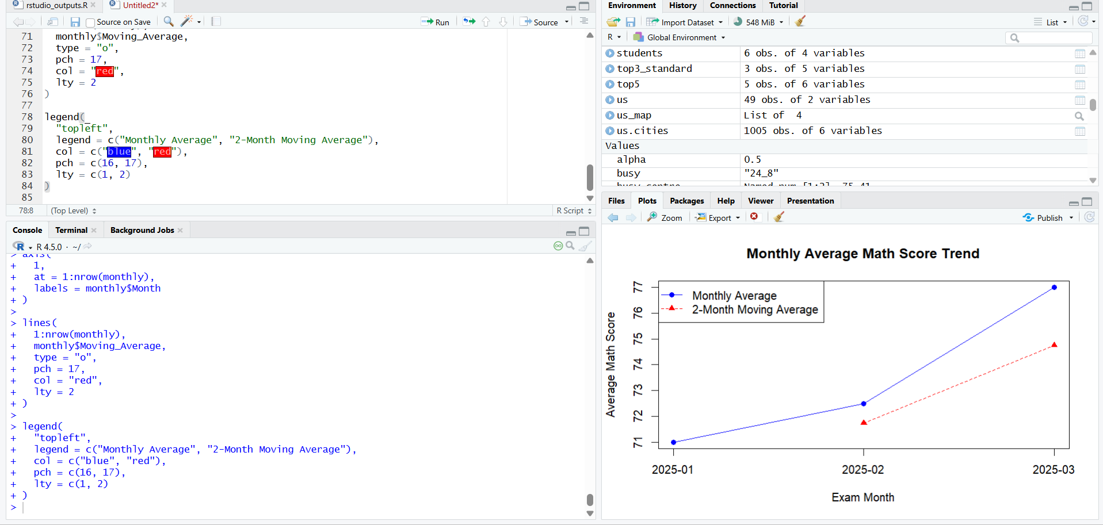

Result and Interpretation
Monthly average Math_Score: January 2025 = 71.00; February 2025 = 72.50; March 2025 = 77.00. The monthly average increases from January to March, indicating an upward trend in this dataset.

Q4. Tableau Dashboard

Aim
Import the CSV into Tableau, create a gender-wise average Math Score bar chart, a score trend line chart over time, add an Exam_Date filter, and assemble an interactive dashboard.

Output Screenshot
